Past Simple or Past Perfect
- I wish I …………………….. (be) taller. I’m the shortest person in my class.  - Before she …………………. (leave) home, Amy ……………………. (put on) some make-up.  - I ……………………………. (feel) offended because my friend ………………………. (call) me an ungrateful princess.  - I wish I ……………………… (not go) to the party. I have a terrible headache now.  - My sister ………………………. (tell) me she ……………………………. (not touch) my stuff in my room but honestly I don’t believe her.  - Before I ………………………. (rush) downstairs to the kitchen, I ……………………….. (make) my bed.  - When Charles ……………………. (enter) his office, he …………………………. (realise) someone …………………………… (search) his drawers.  - Andy ……………………….. (tighten) his safety rope before he …………………….. (start) climbing the rock.  - When the kids ………………….. (come) back home, their dinner …….…………. (be) ready.  - After he ……………………………. (win) the gold medal at the Olympic Games, he …………………….. (decide) to go on holidays.  - Sheila ……………………………….. (jump) with joy after she …………………………… (get) her dream job.  - Lots of people ………………………. (lose) their homes after the tornado …………………………… (sweep) across the country.  - Everybody ……………………. (be) astonished when the rock star ………………………….. (appear) on stage in a very bizzare outfit.  - After he ………………………….. (eat) a fish sandwich, Will ………………………… (have) food poisoning .  - Grandma ………………………. (fall) asleep before her favourite soap opera …………………….. (end). | 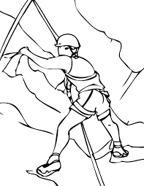  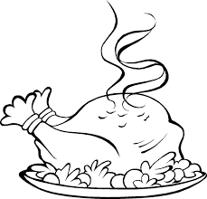  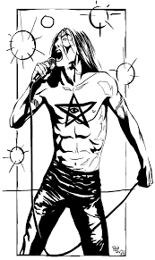  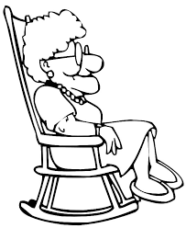

Key:
1. were, 2. left, had put on, 3. felt, had called, 4. hadn’t gone, 5. told, hadn’t touched, 6. rushed, had made, 7. entered, realised, had searched, 8. had tightened, started, 9. came, had been, 10. had won, decided,
11. jumped, had got, 12. lost, had swept, 13. was, had appeared, 14. had eaten, had 15. had fallen, ended

